**[Omok game program](https://github.com/oh930418/oh.github.com/tree/master/Projects/Omok%20game%20program)**

This program is different from the existing Omok game by winning 5 consecutive stones of the same color. If you have 4 stones of the same color, you will get 30 points. If you have 5 stones, you will get 50 points.

You can play against a computer and fight against each other.

If press the 'help' button on a player's turn, player will be able to get help from computer.

*algorithms that the computer plays*

When computer search for attack or defense, computer will find a lot of consecutive stones of the same color. If there are two or more consecutive stones of the same number, check both sides of the consecutive stones and put the stones if there are no stones on both sides.

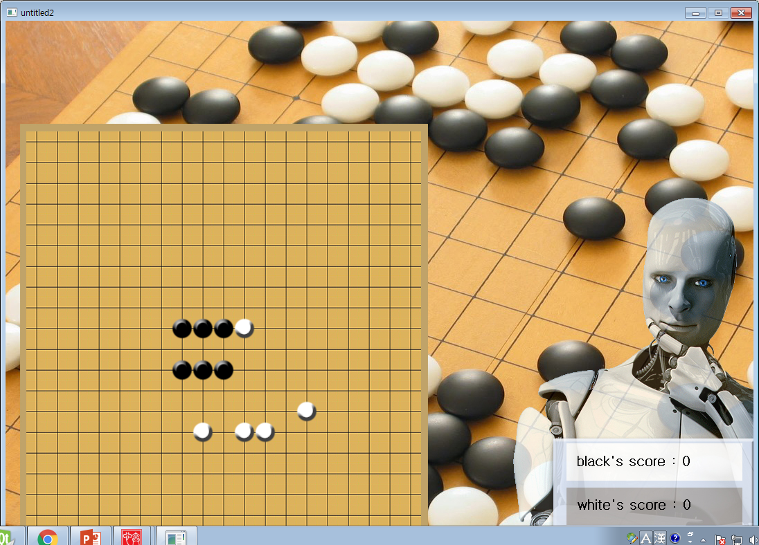

Let's assume that there are continuous stones as shown in the picture above. If the dotted white part is the position where the stone can be placed, place the stone at the bottom because the upper part is clogged on the right and not the bottom part.

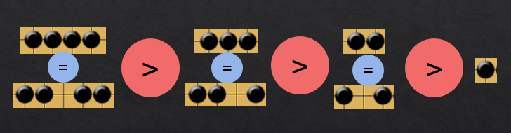

Even if there is blank space in the middle, can equally attack and defend.